Exception Handling

--scenario 1

CREATE OR REPLACE PROCEDURE SafeTransferFunds (

p_from_account IN NUMBER,

p_to_account IN NUMBER,

p_amount IN NUMBER

)

IS

v_balance NUMBER;

BEGIN

SELECT Balance INTO v_balance

FROM Accounts

WHERE AccountID = p_from_account

FOR UPDATE;

IF v_balance < p_amount THEN

RAISE_APPLICATION_ERROR(-20001, 'Insufficient funds in source account.');

END IF;

UPDATE Accounts

SET Balance = Balance - p_amount

WHERE AccountID = p_from_account;

UPDATE Accounts

SET Balance = Balance + p_amount

WHERE AccountID = p_to_account;

COMMIT;

DBMS_OUTPUT.PUT_LINE('Transfer successful from ' || p_from_account || ' to ' || p_to_account);

EXCEPTION

WHEN OTHERS THEN

ROLLBACK;

DBMS_OUTPUT.PUT_LINE('Error: ' || SQLERRM);

END;

/

BEGIN

SafeTransferFunds(1, 2, 500);

END;

/

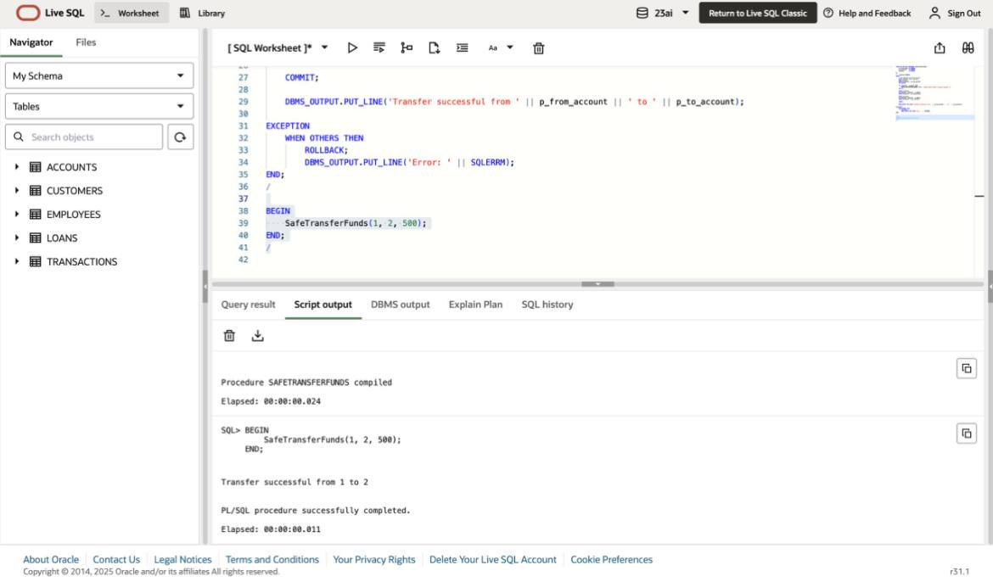

--scenario 2

CREATE OR REPLACE PROCEDURE UpdateSalary (

p_emp_id IN NUMBER,

p_percentage IN NUMBER

)

IS

BEGIN

UPDATE Employees

SET Salary = Salary + (Salary * p_percentage / 100)

WHERE EmployeeID = p_emp_id;

IF SQL%ROWCOUNT = 0 THEN

RAISE_APPLICATION_ERROR(-20002, 'Employee not found.');

END IF;

COMMIT;

DBMS_OUTPUT.PUT_LINE('Salary updated for Employee ID: ' || p_emp_id);

EXCEPTION

WHEN OTHERS THEN

DBMS_OUTPUT.PUT_LINE('Error: ' || SQLERRM);

END;

/

BEGIN

UpdateSalary(2, 10);

UpdateSalary(100, 10);

END;

/



--scenario 3

CREATE OR REPLACE PROCEDURE AddNewCustomer (

p_id IN NUMBER,

p_name IN VARCHAR2,

p_dob IN DATE,

p_balance IN NUMBER

)

IS

BEGIN

INSERT INTO Customers (CustomerID, Name, DOB, Balance, LastModified)

VALUES (p_id, p_name, p_dob, p_balance, SYSDATE);

COMMIT;

DBMS_OUTPUT.PUT_LINE('Customer added: ' || p_name);

EXCEPTION

WHEN DUP_VAL_ON_INDEX THEN

DBMS_OUTPUT.PUT_LINE('Error: Customer with ID ' || p_id || ' already exists.');

WHEN OTHERS THEN

DBMS_OUTPUT.PUT_LINE('Unexpected Error: ' || SQLERRM);

END;

/

BEGIN

AddNewCustomer(31, 'Mohan Raj', TO_DATE('1995-01-01', 'YYYY-MM-DD'), 3000);

AddNewCustomer(31, 'Mohan Raj Again', TO_DATE('1990-01-01', 'YYYY-MM-DD'), 3000); -- Should fail

END;

/

